**Lab - Adding a Printer to the Network Using TCP/IP**

**Overview**

A class of printers, often called network printers, are specifically designed for connecting through a computer network. A networked printer connects to a wired or wireless network. It may be Ethernet enabled and be cabled to an Ethernet switch, or it may connect to a Wi-Fi (wireless) network, or both. Larger businesses have for a long time integrated these printers into their company networks for their employees to share.

Network printers typically allow entering configuration data through a small keypad and screen on the front of the unit.

Click on Start and click on **Control Panel tile.**

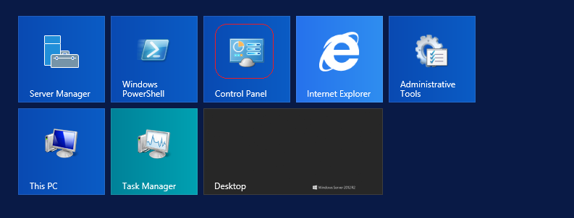

Inside **Control Panel**, go to **View Devices and Printers**.

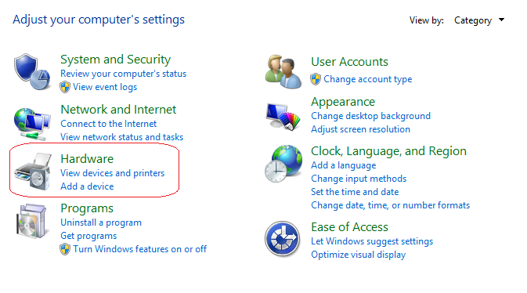

On the next window, select Devices and Printers.

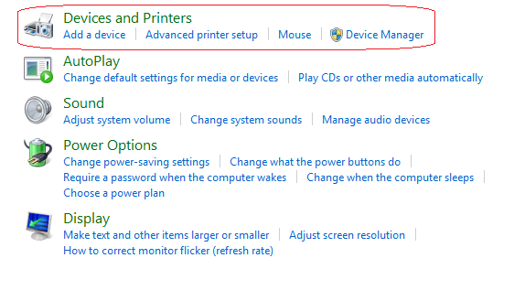

Chose to **Add a Printer**.

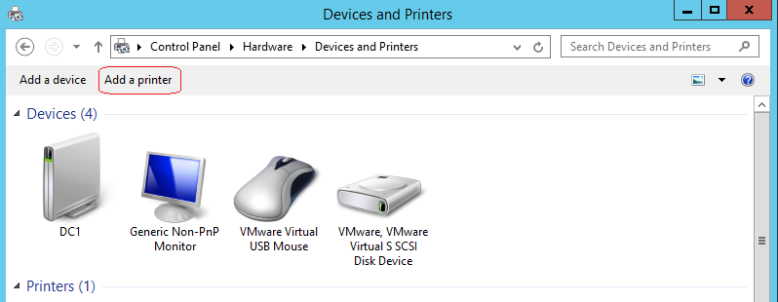

Assuming your printer is not found, go to **‘The Printer I want was not listed.’**

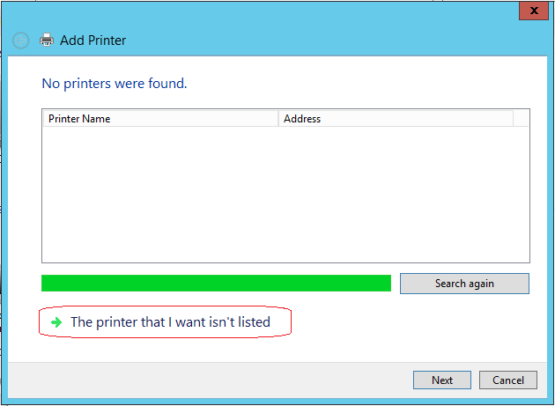

On the next page, under **Find a printer by other options**, click the radio button to **Add a printer using a TCP/IP address or hostname.** Click **Next.**

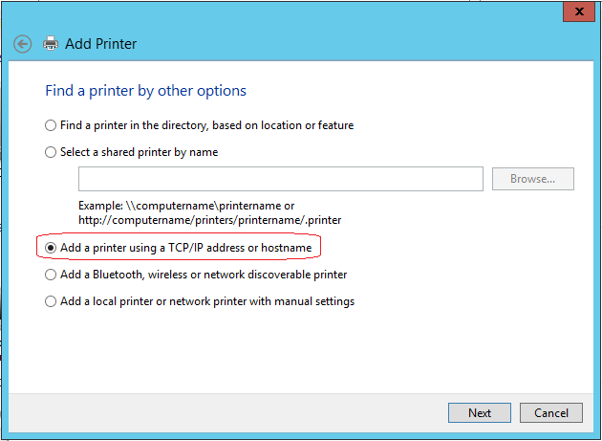

Type in the **IP Address** of the printer.

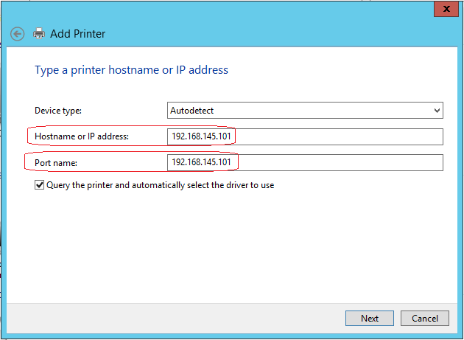

The Server will attempt to locate the printer and then move on detecting the TCP/IP port.

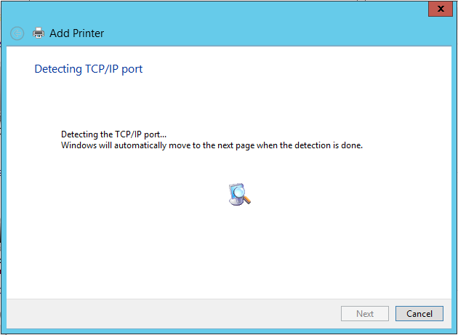

Since the device was not detected, the printer wizard needs some more information. Under the device type, leave it as standard and select the Hewlett Packard Jet Direct.

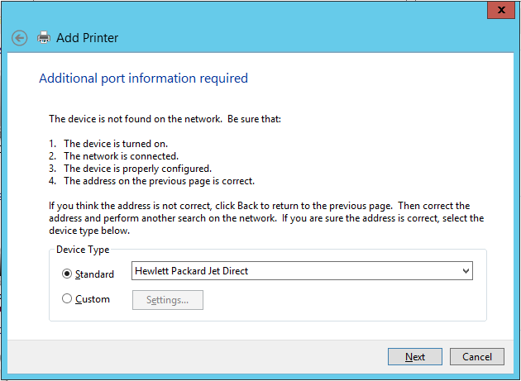

Windows will attempt to find the HP printer to no avail.

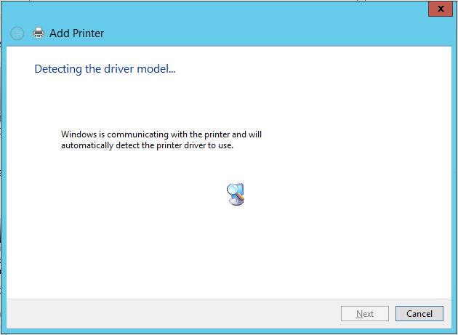

After the detection has ended, we are presented with the add the printer manually option. In the left Windowpane, select HP from the list and in the from the right Window pane select the HP

LaserJet 4200/4300 PCL6 Class Driver. The great thing about Microsoft and HP is Microsoft includes so many of the drivers needed to install HP printers.

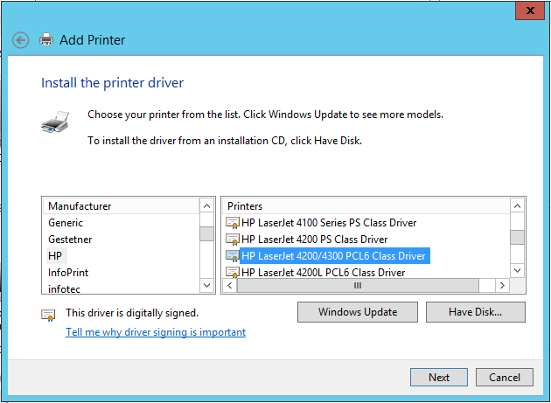

We give the printer a user-friendly printer name. We click next.

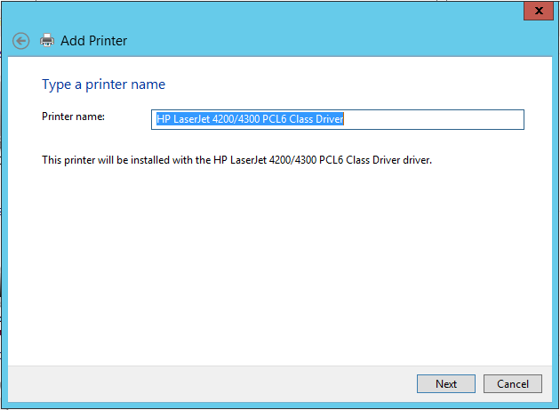

We set up printer sharing, configure a share name and type in the location.

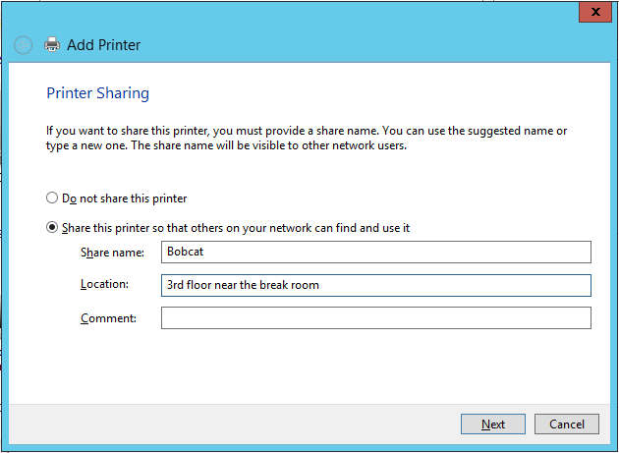

You have the option to print a test page.

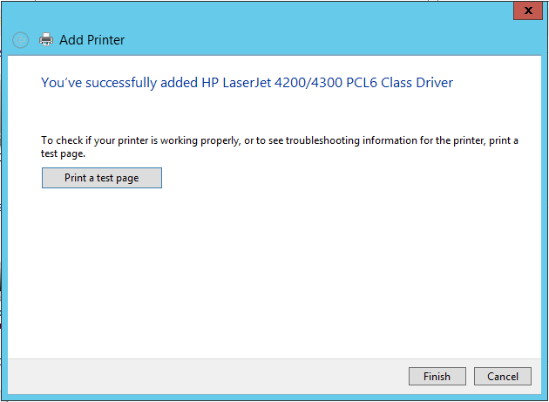

Once that is installed, can go back to the **Devices and Printers** window. Select your Printer and choose **‘Print Server Properties’** at the top of the window.

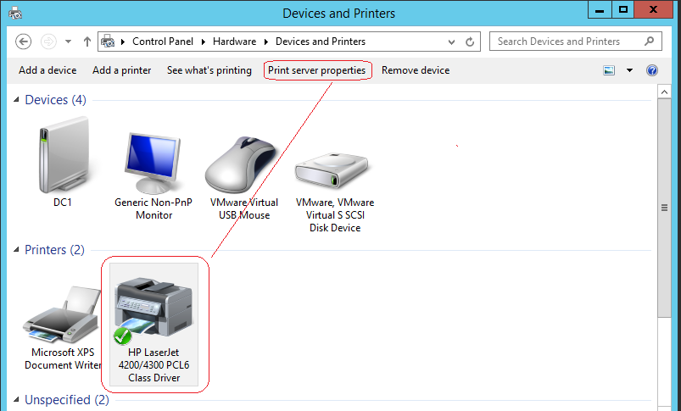

Select the **Drivers** tab, and you can see all the available drivers your server has for printers.

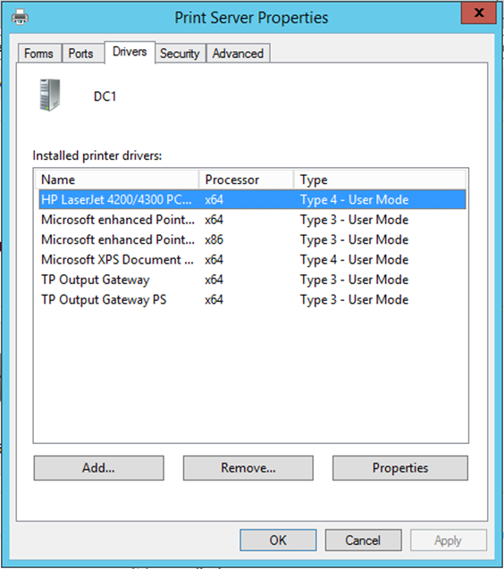

This is where we will add our x86 (32bit) Printer Driver. These need to be downloaded from the printer manufacturer.

On the **Advanced** Page, you can use the Drop-Down menu to select a different Driver. From time to time drivers need to be replaced or updated. When confronted with client printing issues, the first thing we look for is an updated driver. A printer needing to be reinstalled could be just a bad print driver.

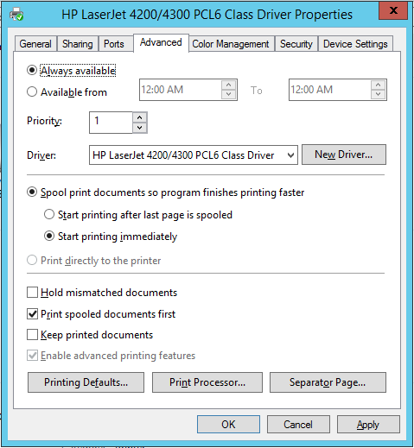

At this point, we can now **Share** the printer. You can choose the **Share name**, and check the box to list the printer in the directory.

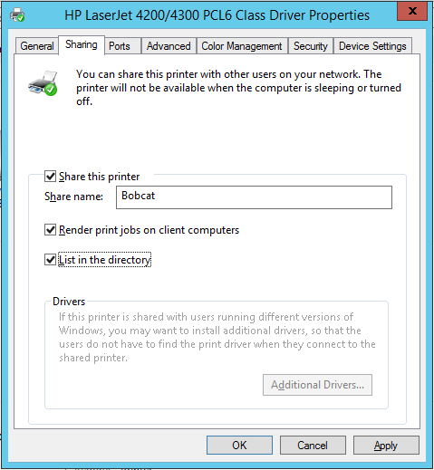

At this point, we have installed a printer, installed the drivers.

**Installing a Network Printer on a Client**

Open your Windows 7 client. Go to start and in the search box type in \\<name of print server> Hit enter.

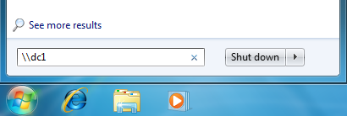

This brings up all the shares available on DC1. Right-click on the Bobcat printer and select connect.

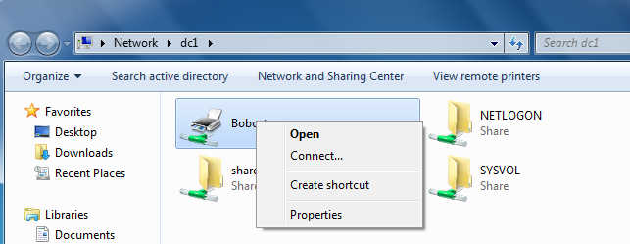

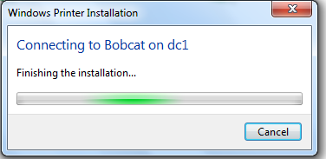

Close out the DC1 shares. Click on start, go to Devices and Printers and locate your new printer.

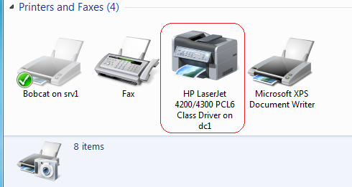

**Summary**

Though we could have used the print manager installed on DC1 to configure a network printer, this is seldom how it is normally done. Most small to medium size organization used the method we just demonstrated in this lab to install a network printer. Additionally, we don’t go around to every client installing the network printer using a disk and the printer’s TCP/IP address. That would be administratively burdensome. We install the printer one time and share it out.

Printers are high dollar item, and everyone wants one sitting on their desk but having a high-end printer that people can print close by cuts expenses and reduces the administrative overhead. The trick is to hold the line in using just one print manufacture. Keeping all your HP printers firmware and software updated is a breeze when using HP’s Web Jetadmin network print management software. <http://h20566.www2.hp.com/hpsc/doc/public/display?docId=c01943164>

End of the lab!